RESULTS

Q1:

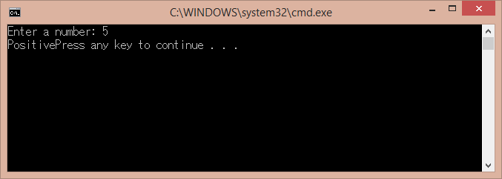

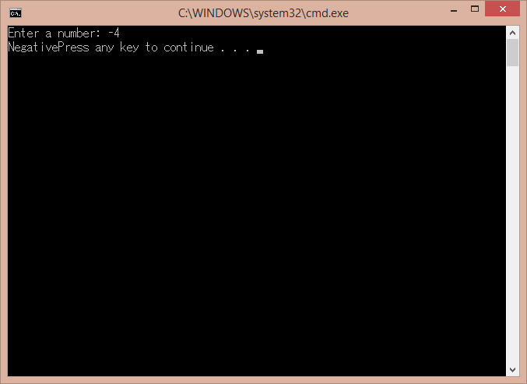

Q2: 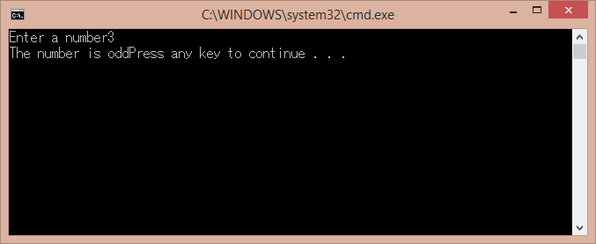

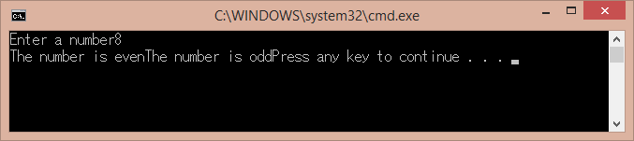

(IT prints out both of them first because it continues to read the numbers)

Q3:

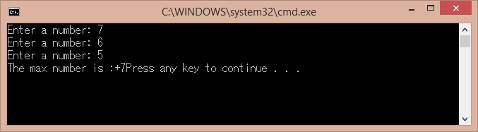

Q4:

